Transcript of Video 8 Self-Reliance

Now I learned How to Do it

Interactions (0:01 to 0:57)

John: Can you take it off?

Eishin: How? I can’t.

John: Yes you can.

Wakako: (Giggles) 0:13

Eishin: Ah. . .

Eishin: Ah. It’s . . . 0:36

John: Now turn that.

Eishin: Turn it? OK?

John: That’s fine.

Wakako: Ahh!

John: Ehm.

Eishin: I did it.

My Reflections (0:58 to 3:07)

John: Ehm. Same idea. If you don’t understand this, you keep trying, go back, try. So you try one way, you try it another way. He said he couldn’t do it. He was lying.

You can always do it. You can always do it if you 1:12
just try alternatives. And infer. That’s the same thing.

When you open a door you have to infer. Does it go to the right or to the left? Out or in? It’s the same, everyday. So we have to do in our room the same as we do everyday.

Always solving problems. If you don’t have a problem, you can’t learn.

Thank you. Now what was I going to say? I forgot.

Oh, I said you know if you print this way, you save 1:41
a lot of ink, which was a stupid comment. But the point is when you take notes in class, or if you are talking to someone and you want to remember, when they speak very quickly, you can do the same thing. Just write the first letters of some words.

Of course, it’s better to do the capital and the punctuation but I took that out to make it more difficult.

And many interpreters when a person is speaking a language and another person has to interpret into Japanese, they take notes and many times they put down sketches in their notes to help to remember what the main point is.

So interpreters use sketches, in chemistry we use a lot of symbols so why not in English also?

(John points to this handout from 1.5 The origin of cloze tests, page 41)

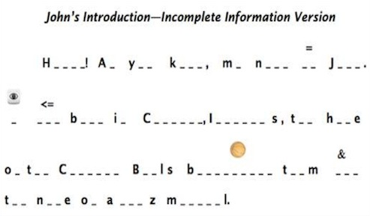

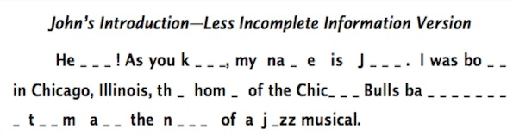

John: Thank you.

So you can put this back in now.
(Hands Eishin the cufflink) 2:33

Eishin: Now I learned how to do it.

John: “Now I learned how to do it.” Notice that he said, “I learned how to do it.” you learned this. I didn’t teach you.

(Some inaudible words from the videographer.)

PS Remarks after the fact

When teachers see this video clip, their commonest reactions are:

1. “What does taking off a cufflink have to do with language teaching?”

2. When are students of the age of Eishin and Wakako going to use cufflinks? Never probably. So what is the need for them to learn how to take them off since they will never put them on??

3.They have not even learned the name of the thing that Eishin took off that had joined the two sides of his shirt cuff like a button.

In 1938, John Dewey’s Education and experience was published. Two central messages Dewey discussed were that we learn by solving problems and by doing. Showing learners what to do and how to do something failed to take advantage of people’s natural curiosity to learn.

In Video 12, Wakako takes two and one half minutes to discover them meaning of dismounted. After she got the meaning she said “Got it.” just as Eishin said, “Now I learned how to do it.” Remember she said 3 times she had no idea what dismounted meant. And Eishin asked “How? I can’t.” in line two.

In Video 8, 56 words are said. Of these 46 are function or glue words like do, it, etc. And only 10 are words with experiential meaning like take, turn, etc. And the experiential/content word cuff link is not mentioned!

In the exchanges I said 38 words. But of these 38, 13 were repetitions of words Eishin had said so I said 25 words. Eishin said 17 words.

But the word count fails to reveal Eishin’s crucial statement, “Now, I learned how to do it.” So while counting words has some uses and contrasting the number of experiential and glue words can be useful, we cannot ignore the content or meaning of the words.

Do a freeze frame of Wakako as Eishin tries to take the cuff link off of my shirt. Most viewers say that she is totally absorbed in the task as if in her mind she is also trying to remove the cuff link.

No reason for her to be involved. She could be looking at the person making the video or me or out the window. But she is fixated on Eishin’s fingers.

So it is true that very little language is used by me, Eishin or Wakako. And it is also true that neither of the are likely ever to have to put on a cuff link in a blouse or shirt, or take cuff links out. And it is even more unlikely that they will ever hear or see the word cuff link.

But they might well remember that learning is problem solving and doing, not memorizing or repeating or copying.

Self-reliance is more likely to be developed when learners have opportunities to learn by performing tasks that allow them to experiment, to predict and solve problems than by tasks that require memorization or copying what others do.

Compare freeze frames of a couple of students trying to memorize “I took of John’s cufflink,” or copying “I took off John’s cufflink from the board,” or memorizing one of the definitions of cuff link such as “a device for fastening together the sides of a shirt cuff, often decorative.”

Of course at some point the words device, fastening together, sides of a shirt cuff, decorative might have to be checked. But even if we understand these words our understanding would not necessarily help us take off or put on a cuff link.

Seeing the cufflinks on my shirt and taking one off provides more information than a definition. Here is an image of a pair of cufflinks which most find more helpful than a definition.

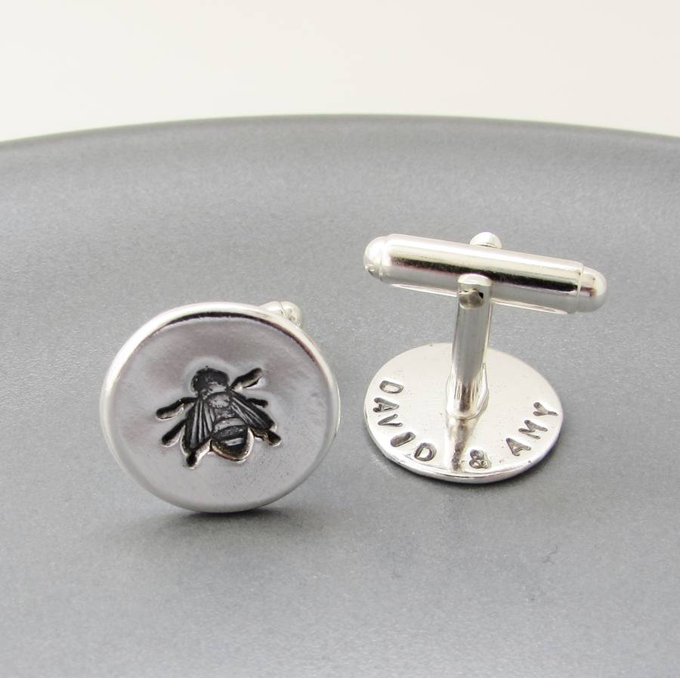

A pair of cuff links
At the end of my PS for Video 12, I quoted F. L. Billows
about the relationship between language and experience. Here it is again:
“The material of the language lesson is not language, but life itself; the language is the instrument we use to deal with the material, slices of experience.” (F. L. Billows, The Techniques of Language Teaching. Longman, 1961)

1094 Words

